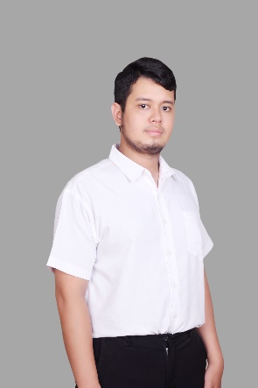Dias Raihan Ichsandy

A chemical analyst with four years of experience and a bachelor's degree in industrial engineering who is now shifting to be a data analyst.

I am data enthusiast that passionate to work with data. I enjoy to work with data analysis process from asking and understanding business problem, preparing, processing, analyzing, interpreting, and delivering the result into actionable insight.

I have good analytical thinking, problem-solving skills, and an eagerness to learn new things. In my life, there is no time to waste without learning and improving myself.



|  |  |  |
| --- | --- | --- |
| [082246626465](https://wa.me/6282246626465) | [Dias Raihan Ichsandy](https://www.linkedin.com/in/dias-raihan-ichsandy-814510161/) | Cikarang Baru, Kabupaten Bekasi |
| [diasraihan121@gmail.com](mailto:diasraihan121@gmail.com) | Github Logo - Free social media icons Portfolio: <https://diasraihan.github.io/portfolio/> |  |

# Work Experience

QC Chemical Analyst • PT Takeda Indonesia

Juli 2018 - Present

* Perform chemical analysis testing for raw material, packaging material, finished good, stability product, water, and waste.
* Operate instrumental chemical analysis with HPLC, Spectrophotometer UV-Vis & IR, Karl Fischer, and other pharmacy analytical instruments.
* Perform sampling and analytical testing for the production process and cleaning.
* Perform analytical method validation.
* Sampling raw material, packaging material, and finished goods sample for laboratory testing.

# Education

2018 - 2022

## President University

Industrial Engineering

GPA: 3.46/4

2014 - 2018

## SMK - SMAK Bogor

Chemical Analyst

# Certificates

|  |  |
| --- | --- |
| RevoU – Full Stack Data Analytics**Certificate link: Coming soon on this May 2023**  * Understanding Business Problems * Statistics * Spreadsheets * SQL * Python Programming Language * Data Visualization (Tableau and Looker Studio) * Data Communication | May - Apr 2023 |

|  |  |
| --- | --- |
| Coursera – Google Data Analytics**[Here the certificate link](https://www.coursera.org/account/accomplishments/specialization/certificate/TAUZR7HEJ6SG)**  * Foundations: Data, Data, Everywhere * Ask Questions to Make Data-Driven Decisions * Prepare Data for Exploration * Process Data from Dirty to Clean * Analyze Data to Answer Questions * Share Data Through the Art of Visualization * Data Analysis with R Programming * Google Data Analytics Capstone: Complete a Case Study | Oct - Dec 2023 |

|  |  |
| --- | --- |
| Skills | Languages |
| |  |  | | --- | --- | | * Data Analytics * Spreadsheets * SQL * Python Programming | * R Programming * Tableau * Looker Studio * Data Communication | | * English * Indonesian |